Gas Dispersion Prototype — Model Design
Oct 4, 2026 · @Adyaan Ahmed

Purpose
This document specifies the gas dispersion model for the H₂S prototype. The spatial environment model and the agent model are complete; this design covers the gas model and its integration with them. The prototype must show where released H₂S travels outdoors and inside buildings, when the alarm triggers, and how site personnel respond.
- In scope: a single gas (H₂S), one or more release sources, time-varying wind and weather, room-by-room indoor infiltration, and coupling with the existing map and agent models.
- Out of scope: fire and explosion, dense-gas behaviour, building-resolved airflow (CFD), room-to-room transport, and live sensor feeds.
- Acceptance criteria: a scenario runs end to end on the map, showing the outdoor plume, per-room concentrations, the alarm triggering at 30 ppm, and agents responding.

System architecture
The system has three models coordinated by a simulation core: the spatial environment model (site, buildings, rooms), the agent model (personnel and behaviour) and the gas dispersion model (concentrations). The core owns the clock and schedules updates; models interact only through defined interfaces.
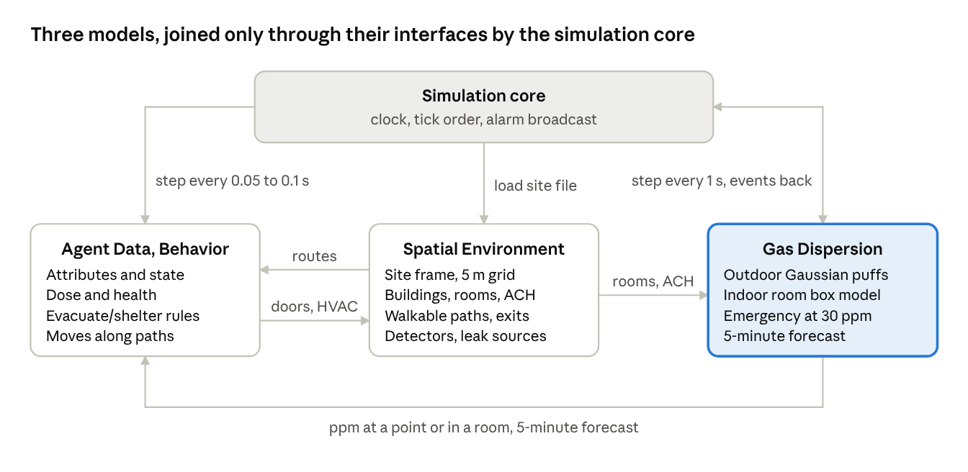
system overview · 3 models + simulation core
The map supplies geometry to both other models. The gas model supplies exposure data to agents, and agent actions (closing doors, switching off HVAC) update the map, which changes indoor infiltration rates. This feedback loop is what gives shelter-in-place its effect.

Existing models
The spatial environment and agent models are complete. The gas model uses their existing interfaces and the shared coordinate frame (metres; x east, y north; origin at the site's south-west corner).
Model | Provides to the gas model | Receives from the gas model
Spatial environment | Site grid (1 km × 1 km, 5 m cells), building footprints, room volumes, air changes per hour (ACH), HVAC and door state, detector and release-source locations | —
Agent | Door and HVAC state changes (applied through the map) | Concentration at each agent's location, alarm state, 5-minute forecast

Gas dispersion model
The model computes H₂S concentration (ppm) every simulated second across the outdoor grid and in every room. It uses a Gaussian puff model outdoors and a well-mixed box model for each room.

Inputs
Input | Parameters | Source
Release | Location, height, type (instantaneous tank rupture or continuous pipe leak), mass or rate | Scenario file
Meteorology | Wind speed and direction, temperature, pressure, precipitation, humidity, stability class | Scenario file or recorded data
Site | Room volumes, ACH, HVAC state, detector locations | Spatial model

Outdoor: Gaussian puffs
A continuous release is discretised into puffs emitted every few seconds; an instantaneous release is a single puff. Each puff advects with the current wind and grows with travel distance, so the plume follows wind shifts naturally. Concentration at any point is the sum over all puffs, with ground reflection:
C(x,y,z,t) = \sum_i \frac{M_i}{(2\pi)^{3/2}\,\sigma_{x}\sigma_{y}\sigma_{z}} \exp\!\left(-\frac{(x-x_i)^2}{2\sigma_x^2}-\frac{(y-y_i)^2}{2\sigma_y^2}\right)\left[e^{-\frac{(z-H)^2}{2\sigma_z^2}}+e^{-\frac{(z+H)^2}{2\sigma_z^2}}\right]
Here Mᵢ is the puff mass, (xᵢ, yᵢ) its centre, H the release height and σ the dispersion coefficients. Receptor height is 1.5 m (breathing zone).
- σ values follow Pasquill–Gifford stability classes with Briggs parameterisations, as in ALOHA.
- Wet deposition removes a fraction of puff mass per second during rain.
- Output in mg/m³ is converted to ppm using ambient temperature and pressure (1 ppm ≈ 1.39 mg/m³ at 25 °C).
- A steady-state Gaussian plume is retained as a fast mode and a verification check; under constant wind the two must agree.

Indoor: box model
Each room is a single well-mixed volume exchanging air with the outdoor concentration at its location:
\frac{dC_{in}}{dt} = \lambda\,\big(C_{out} - C_{in}\big), \qquad \lambda = \frac{\text{ACH}}{3600}\ \text{s}^{-1}
- Indoor concentration lags and peaks below the outdoor level, which is the basis for shelter-in-place.
- HVAC on increases λ; HVAC off with doors closed reduces it; an open external door raises it temporarily.
- Room-to-room transport is excluded from this version.

Outputs
Output | Description | Update rate
Concentration field | ppm on every 5 m cell at 1.5 m height | 1 s
Point query | ppm at any outdoor location | On request
Room concentrations | ppm in every room | 1 s
Alarm state | Normal, warning or emergency; emergency latches when any detector reads ≥ 30 ppm for a set duration | 1 s
5-minute forecast | Projected concentration field and time-to-hazard per location | ~30 s

Integration
The gas model updates at 1 s; agents step at 10–20 Hz and read the most recent gas values between gas updates. Each simulated second proceeds as follows:
- Meteorology updates from the scenario script or recorded data.
- The gas model emits and advects puffs, recomputes the outdoor field and updates every room.
- Detectors are evaluated; a sustained reading of 30 ppm or more triggers the alarm.
- The core broadcasts the alarm state to all agents.
- Agents query their exposure and act; door and HVAC changes are written to the map and take effect on the next gas step.
- The 5-minute forecast refreshes roughly every 30 s.
- State is rendered and logged for replay.
Design rules:
- Models communicate only through defined interfaces, so a fire model could later plug in alongside gas.
- A single scenario file defines each run; each model owns its own section.
- Runs are deterministic for a given random seed.

Implementation plan
- Confirm the gas model's interfaces with the spatial and agent models, and its section of the scenario file.
- Outdoor dispersion: steady-state plume, then puffs under time-varying wind, rendered as a heatmap.
- Indoor box model, with rooms shaded by concentration.
- Detector logic, alarm states and the 5-minute forecast.
- Coupling with the agent model; full scenario run with replay.
- Validation against ALOHA on reference cases.

Limitations
- H₂S is treated as neutrally buoyant. It is slightly denser than air, so large ruptures would hug the ground; dense-gas modelling is out of scope.
- Outdoor dispersion ignores obstruction by buildings and pipe racks, which only CFD resolves and is too slow for real time.
- Each room is one well-mixed volume with no inter-room exchange.
- Gaussian models typically agree with ALOHA to within a factor of about 2; a written comparison will accompany step 6.

Open questions
- ☐ Is the puff model outdoors with a box model indoors sufficient for the prototype, or is a higher-fidelity approach (particle model, inter-room transport) preferred?
- ☐ Is 30 ppm the only alarm threshold, or should there be an earlier warning level (10 or 20 ppm)?
- ☐ What release scenarios should be modelled (tank volumes, pipe diameters, operating pressures)?
- ☐ Are site weather records or building ventilation data available, or should typical values be used initially?

